**Title: Times New Roman, 14pt. Bold,**

**Centered, Interline 1.5**

**Authors, underline presenting author: Times New Roman, 12pt. Bold, Centereda**

*(a) Laboratory, Affiliation, Address; Times New Roman, 8pt Italic, Centered*

*Presenting author: E-mail: Times New Roman, 10 pt. Italic, Centered*

**Keywords,** **Times New Roman, 12pt, Bold:** Times New Roman, 12pt.

**Introduction/Objective**

Cmga, cmga, cmga, cmga, cmga, cmga, cmga, cmga, cmga, cmga, cmga, cmga, cmga, cmga, cmga, cmga, cmga, cmga, cmga, cmga, cmga, cmga, cmga, cmga, cmga, cmga, cmga, cmga, cmga, cmga, cmga, cmga, cmga, cmga, cmga, cmga, cmga, cmga, cmga, cmga, cmga, cmga, cmga, cmga, cmga, cmga, cmga, cmga, cmga, cmga, cmga, cmga, cmga, cmga, cmga.

**Methodology**

Cmga, cmga, cmga, cmga, cmga, cmga, cmga, cmga, cmga, cmga, cmga, cmga, cmga, cmga, cmga, cmga, cmga, cmga, cmga, cmga, cmga, cmga, cmga, cmga, cmga, cmga, cmga, cmga, cmga, cmga, cmga, cmga, cmga, cmga, cmga, cmga, cmga, cmga, cmga.

**Result/Discussion**

Cmga, cmga, cmga, cmga, cmga, cmga, cmga, cmga, cmga, cmga, cmga, cmga, cmga, cmga, cmga, cmga, cmga, cmga, cmga, cmga, cmga, cmga, cmga, cmga, cmga, cmga, cmga.

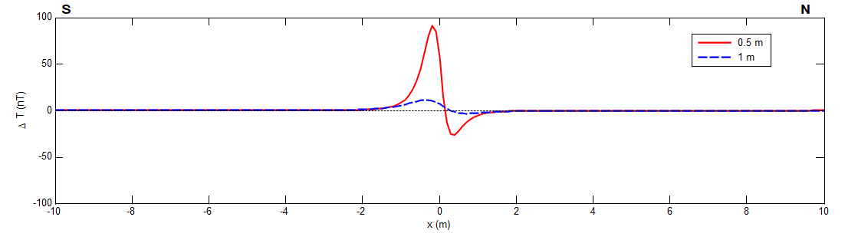

**Figure.1** *This is an example of a figure.*

cmga, cmga, cmga, cmga, cmga, cmga, cmga, cmga, cmga, cmga, cmga, cmga, cmga, cmga, cmga, cmga, cmga, cmga, cmga, cmga, cmga, cmga, cmga, cmga, cmga, cmga, cmga, cmga.

**Conclusion**

Cmga, cmga, cmga, cmga, cmga, cmga, cmga, cmga, cmga, cmga, cmga, cmga, cmga, cmga, cmga, cmga, cmga, cmga, cmga, cmga, cmga, cmga, cmga, cmga, cmga, cmga, cmga, cmga, cmga, cmga, cmga, cmga, cmga, cmga, cmga, cmga, cmga, cmga, cmga, cmga, cmga, cmga, cmga, cmga, cmga, cmga, cmga, cmga, cmga, cmga, cmga, cmga, cmga, cmga, cmga.

**References**

Jallouli C, Mickus K (2000), Regional gravity analysis of the crustal structure of Tunisia. J Afr Earth Sci 30(1):63–78. https://doi.org/10.1016/S0899-5362(00)00008-7

| **Author guidelines**  Maximum 2 pages in word format or maximum 1000 words, Times New Roman, 12 points, 1.15 interline, including text, figures, tables, references and keywords. |
| --- |